Uniform Star Polyhedra

Definition
# Source: AI Source: Provided by: [Data Path: Persons Table -> ID Column: 1, Name_En Column: Motasem Essam] -> From: [ChatGPT] on [7/25/2026]
Uniform Star Polyhedra are non-convex uniform polyhedra whose geometric structures contain intersecting faces, intersecting edges, or star-shaped polygonal elements.
They are characterized by two fundamental properties:
- Regular Faces: Every face is a regular polygon or regular star polygon.
- Vertex Transitivity: Every vertex has an identical geometric arrangement, meaning a symmetry transformation can map any vertex onto any other vertex.
Their geometry extends beyond convex polyhedra by allowing regular star polygons, such as pentagrams, and intersecting arrangements of ordinary regular polygons.
Uniform star polyhedra are also called Non-Convex Uniform Polyhedra or Star Uniform Polyhedra.

Geometric Representation
# Source: AI Source: Provided by: [Data Path: Persons Table -> ID Column: 1, Name_En Column: Motasem Essam] -> From: [ChatGPT] on [7/25/2026]
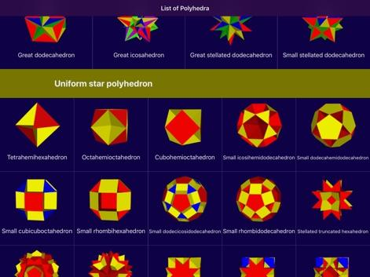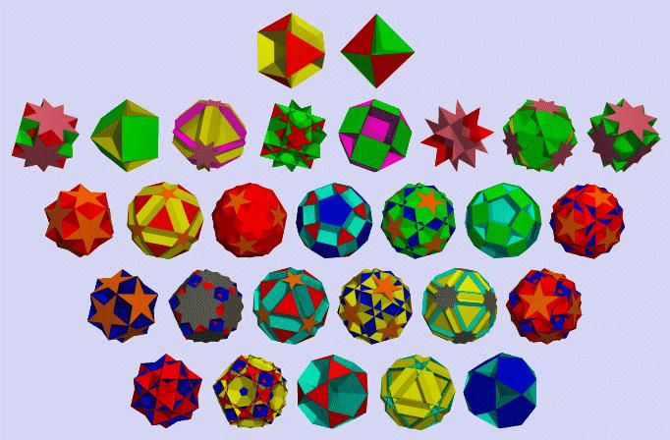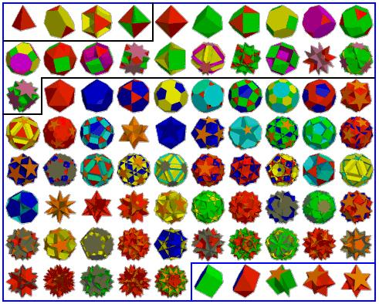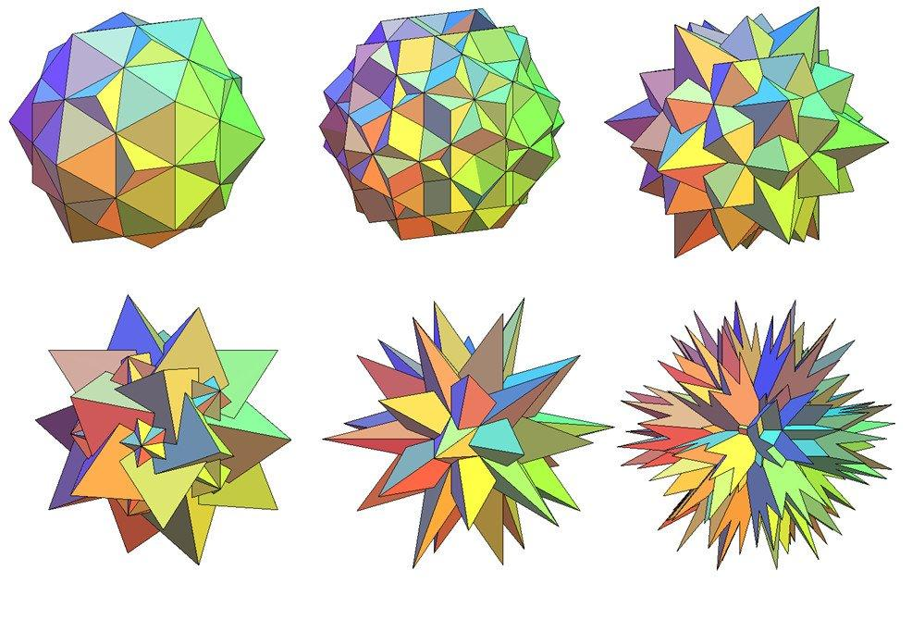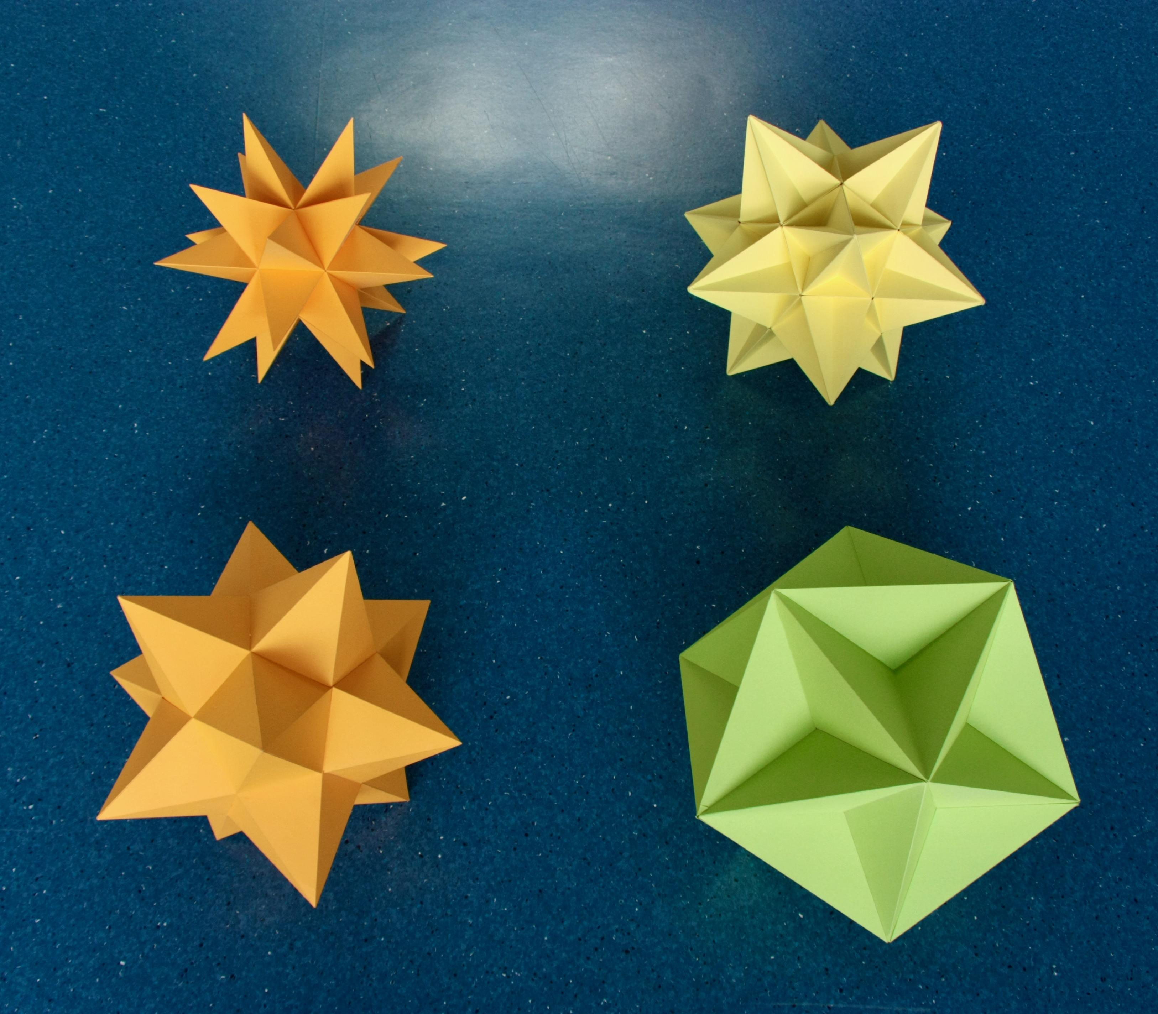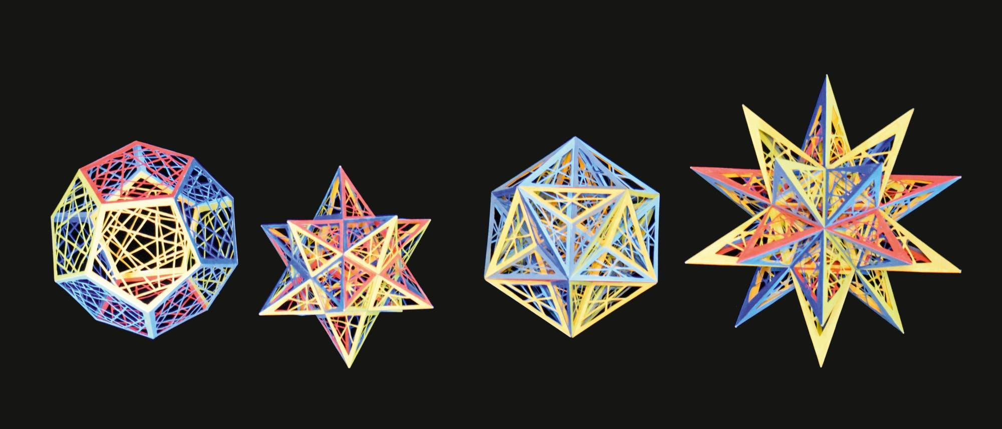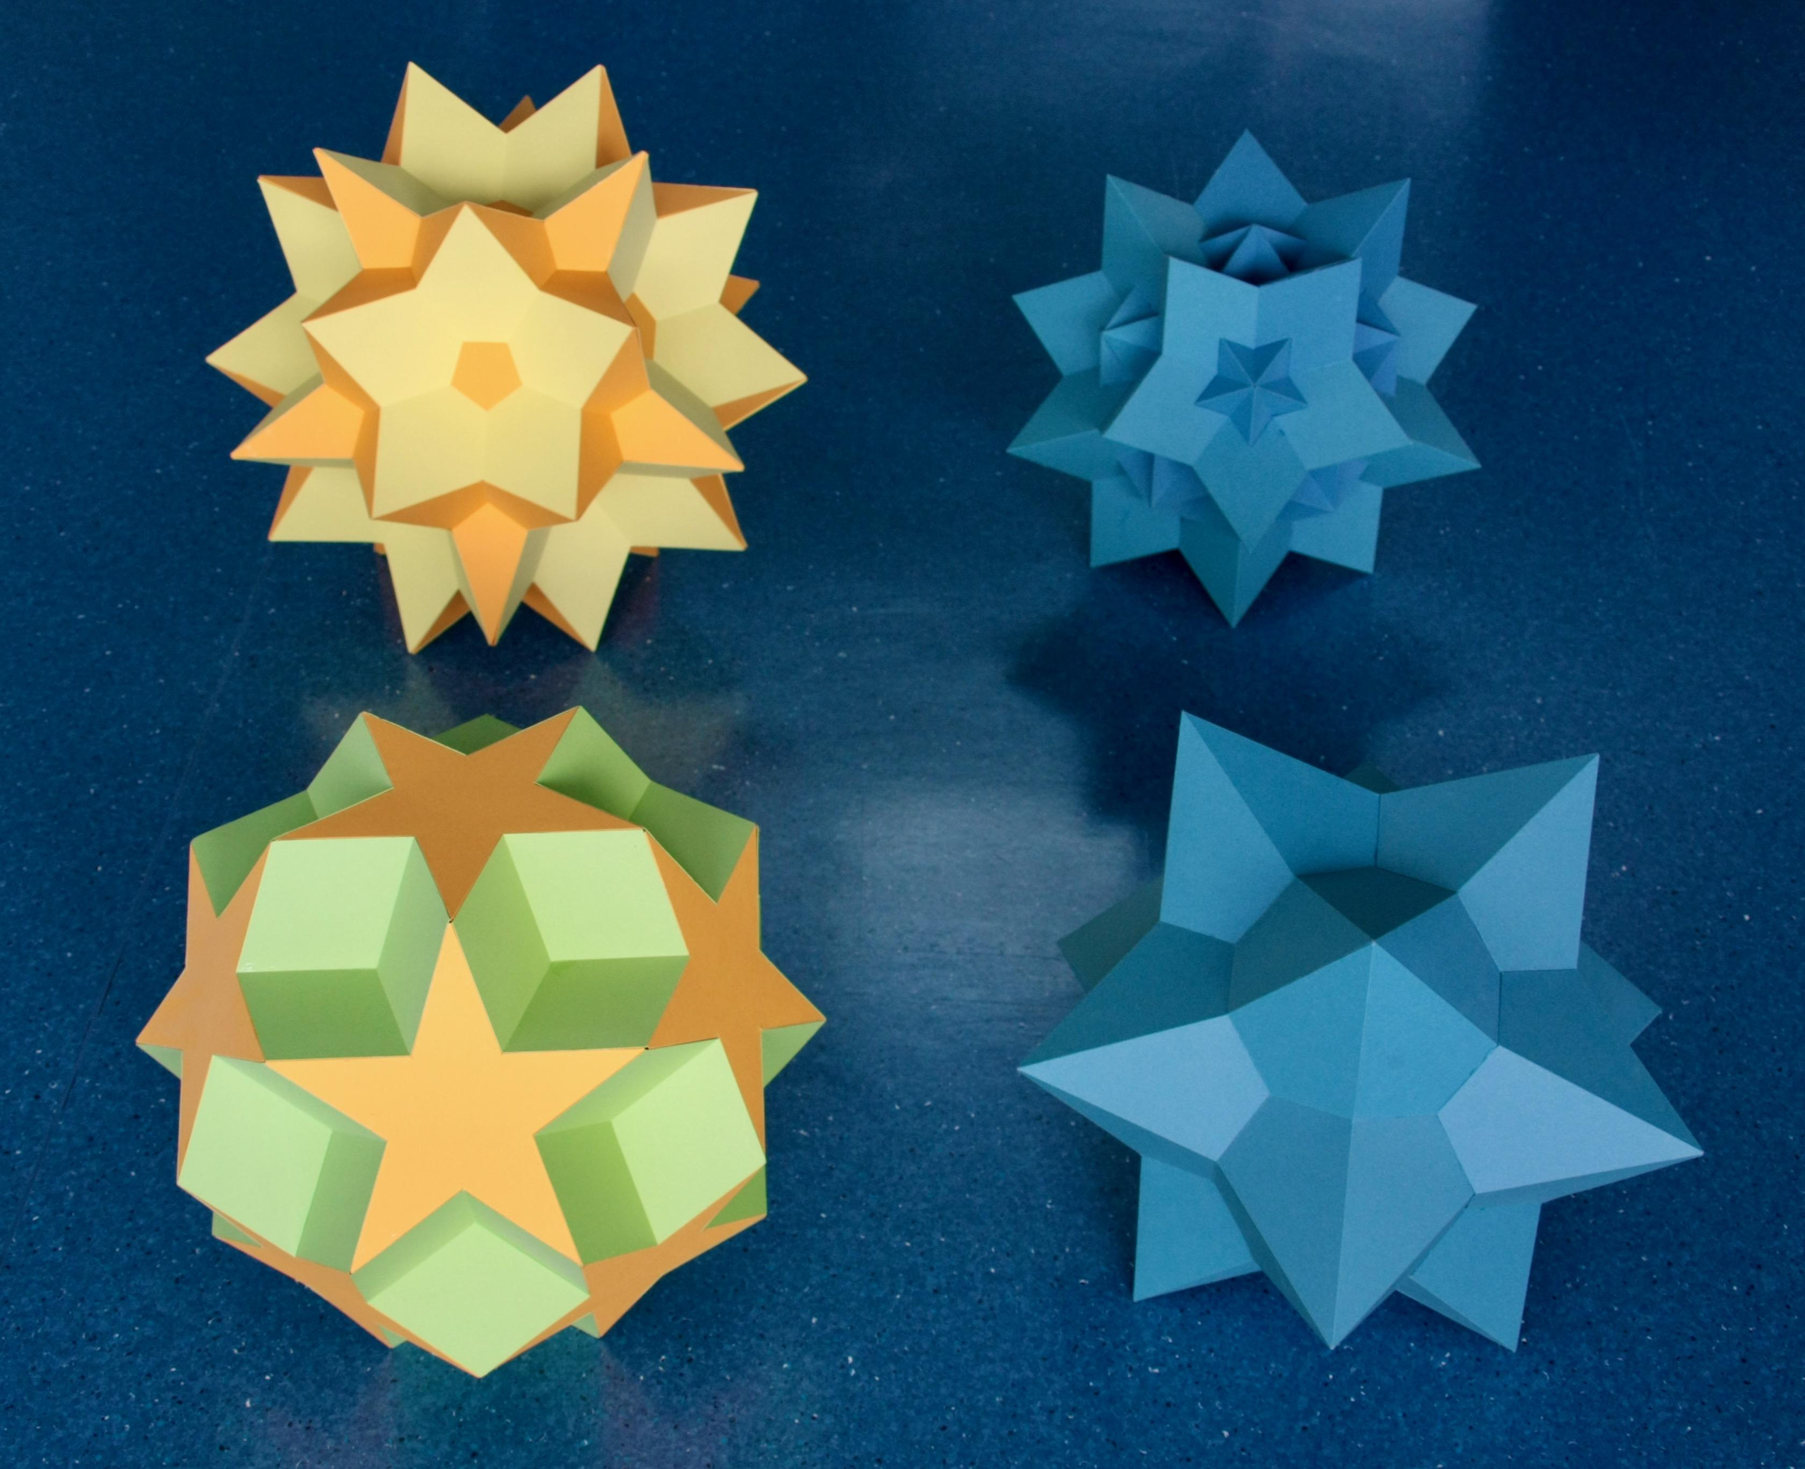

Geometric Structure
# Source: AI Source: Provided by: [Data Path: Persons Table -> ID Column: 1, Name_En Column: Motasem Essam] -> From: [ChatGPT] on [7/25/2026]
Uniform star polyhedra have several distinctive geometric characteristics:
- Non-Convex Structure: Their geometry is not entirely convex.
- Regular Polygonal Faces: Faces are regular polygons or regular star polygons.
- Uniform Vertices: All vertices have congruent arrangements.
- Self-Intersecting Geometry: Faces or edges may intersect one another.
- Star Vertex Figures: Some polyhedra have star-shaped arrangements of faces around their vertices.
- High Symmetry: They possess rotational and, in many cases, reflectional symmetry.
- Multiple Face Types: A single polyhedron may combine different regular polygons and star polygons.
Not every uniform star polyhedron has star-shaped faces. Some use ordinary convex polygons whose overall arrangement creates a self-intersecting solid.

Classification of Uniform Star Polyhedra
# Source: AI Source: Provided by: [Data Path: Persons Table -> ID Column: 1, Name_En Column: Motasem Essam] -> From: [ChatGPT] on [7/25/2026]
The standard classification contains 57 non-prismatic uniform star polyhedra, divided into three groups:
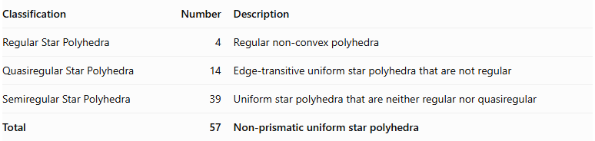
Classification | Number | Description
Regular Star Polyhedra | 4 | Regular non-convex polyhedra
Quasiregular Star Polyhedra | 14 | Edge-transitive uniform star polyhedra that are not regular
Semiregular Star Polyhedra | 39 | Uniform star polyhedra that are neither regular nor quasiregular
Total | 57 | Non-prismatic uniform star polyhedra
There are also two infinite families of uniform star polyhedra:
- Uniform Star Prisms.
- Uniform Star Antiprisms.
The 57 count excludes these infinite families and the exceptional degenerate Skilling figure.

Regular Star Polyhedra
# Source: AI Source: Provided by: [Data Path: Persons Table -> ID Column: 1, Name_En Column: Motasem Essam] -> From: [ChatGPT] on [7/25/2026]
Regular Star Polyhedra are the four Kepler–Poinsot polyhedra.
They have congruent regular star-polygon faces and identical vertex arrangements. They are both face-transitive and vertex-transitive.
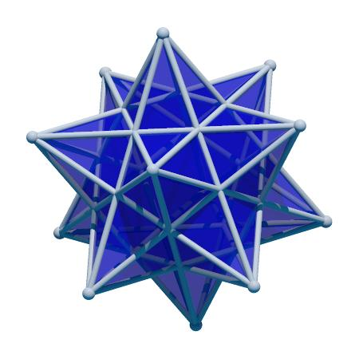
Small Stellated Dodecahedron
$$\{5/2,5\}$$
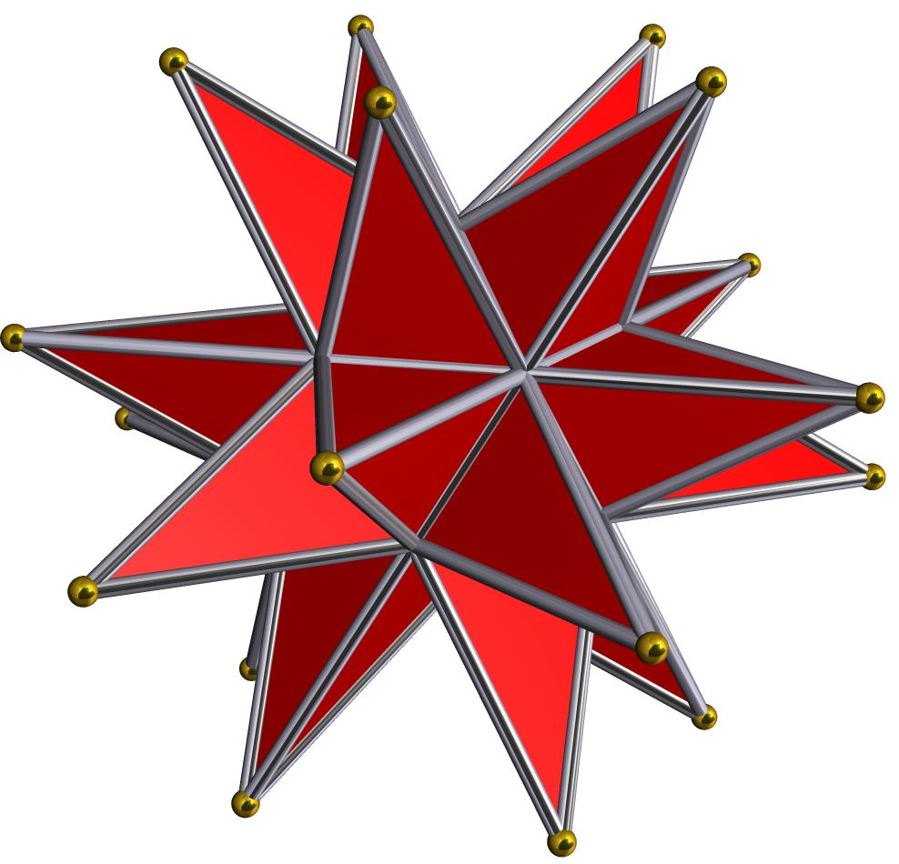
Great Stellated Dodecahedron
$$\{5/2,3\}$$
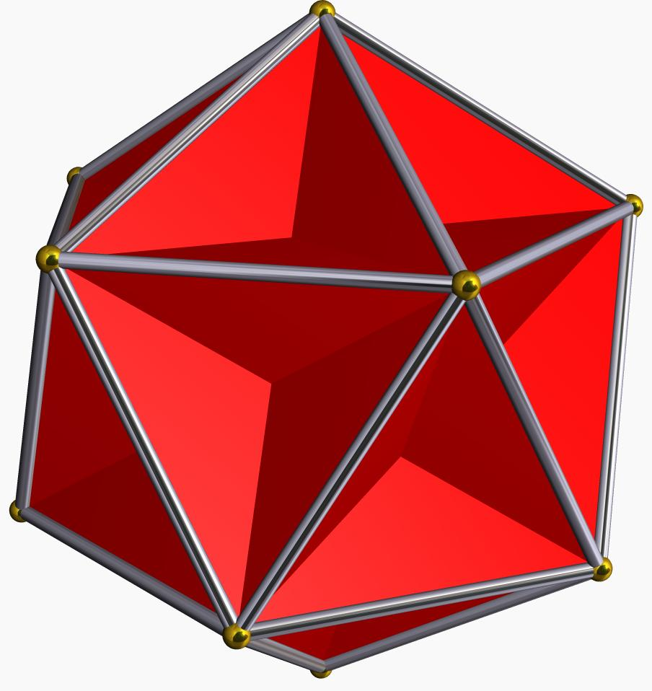
Great Dodecahedron
$$\{5,5/2\}$$
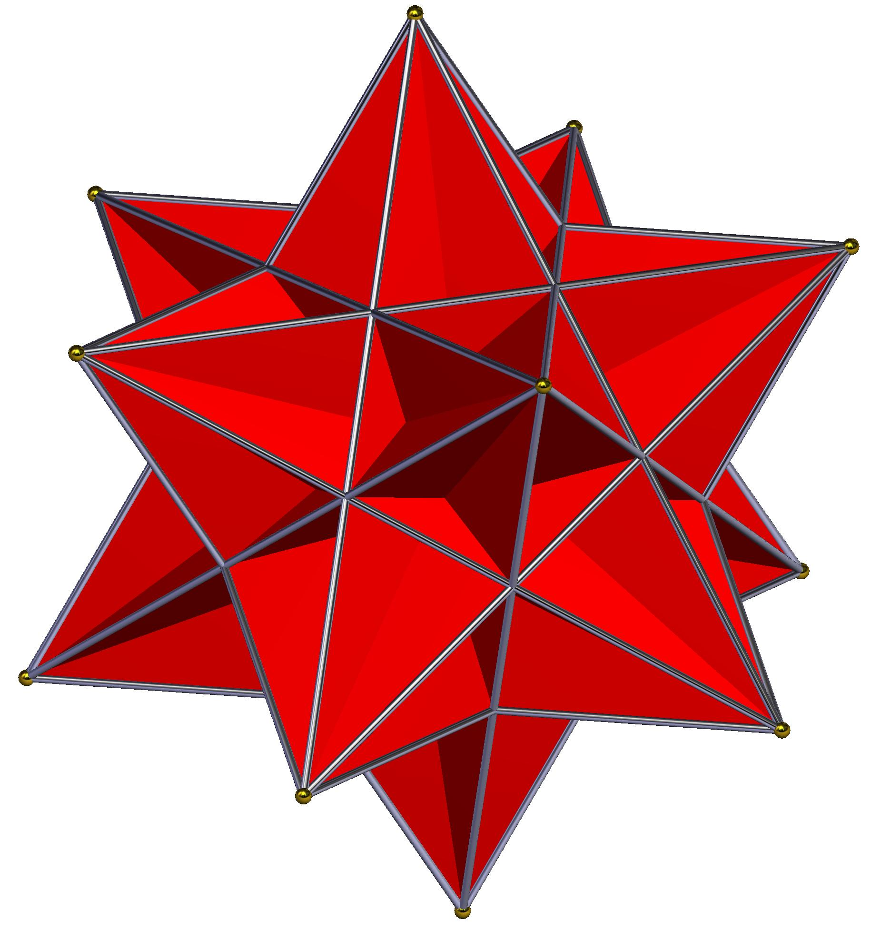
Great Icosahedron
$$\{3,5/2\}$$

Quasiregular Star Polyhedra
# Source: AI Source: Provided by: [Data Path: Persons Table -> ID Column: 1, Name_En Column: Motasem Essam] -> From: [ChatGPT] on [7/25/2026]
Quasiregular Star Polyhedra are uniform star polyhedra that are both vertex-transitive and edge-transitive but not face-transitive.
They contain more than one type of regular face, with their different face types arranged uniformly around the vertices.
Examples include:
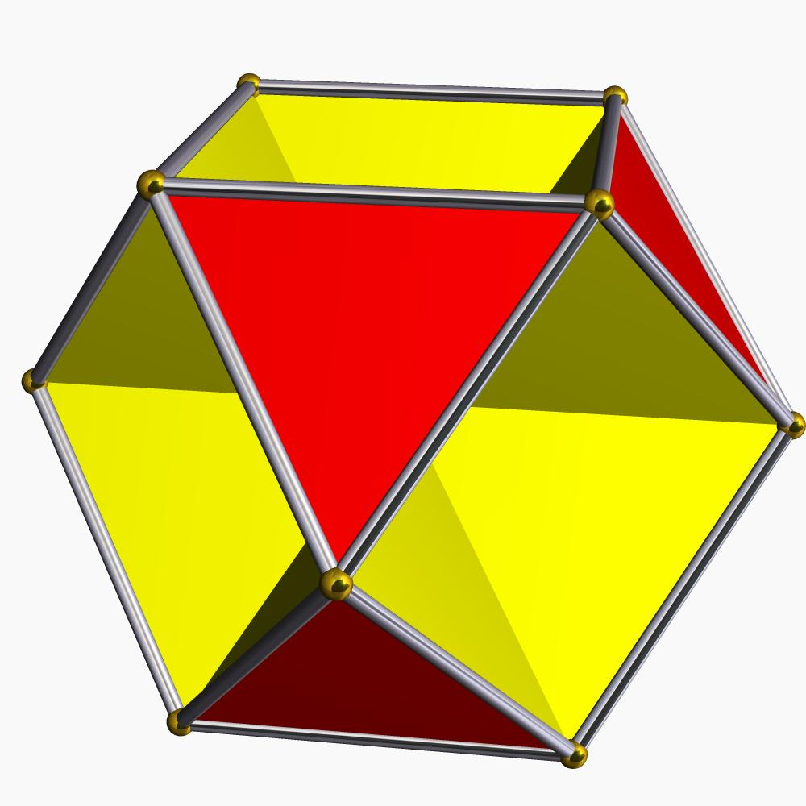
Octahemioctahedron
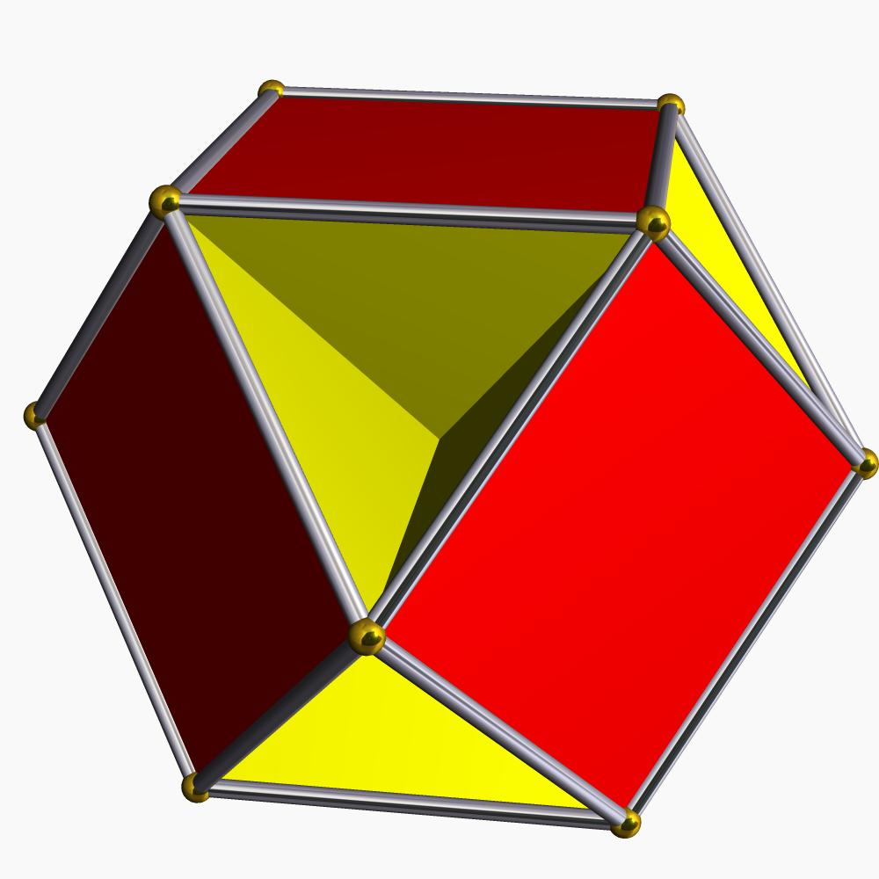
Cubohemioctahedron
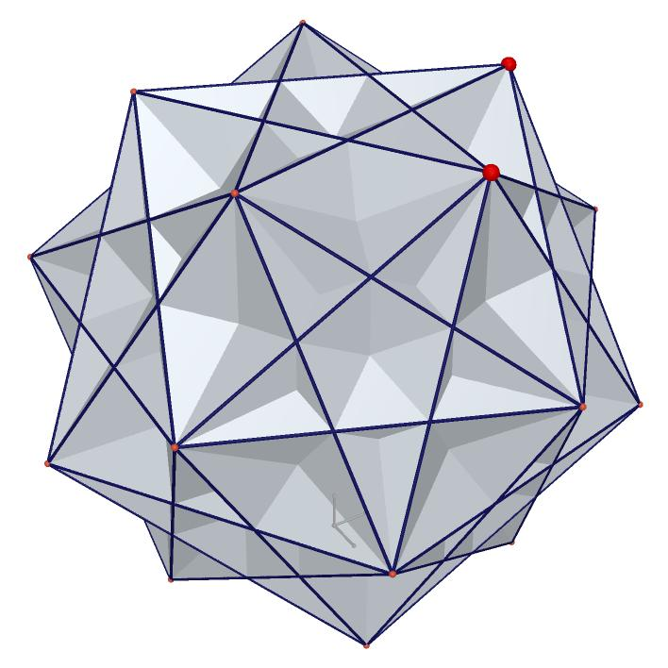
Great Ditrigonal Icosidodecahedron
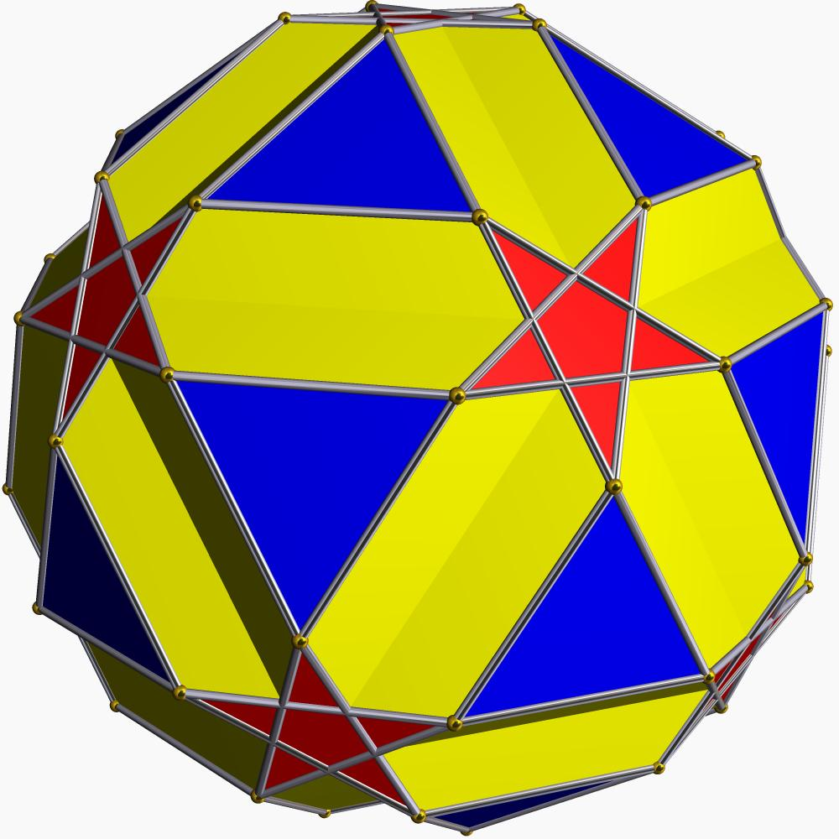
Small Icosicosidodecahedron
These are examples of quasiregular forms; the complete classification contains 14 quasiregular star polyhedra.

Semiregular Star Polyhedra
# Source: AI Source: Provided by: [Data Path: Persons Table -> ID Column: 1, Name_En Column: Motasem Essam] -> From: [ChatGPT] on [7/25/2026]
Semiregular Star Polyhedra are uniform star polyhedra that are vertex-transitive but are neither face-transitive nor edge-transitive.
They can contain:
- Multiple types of regular polygonal faces.
- Regular star-polygon faces.
- Star-shaped vertex figures.
- Intersecting convex polygonal faces.
- Complex combinations of regular and retrograde polygonal arrangements.
Examples include:
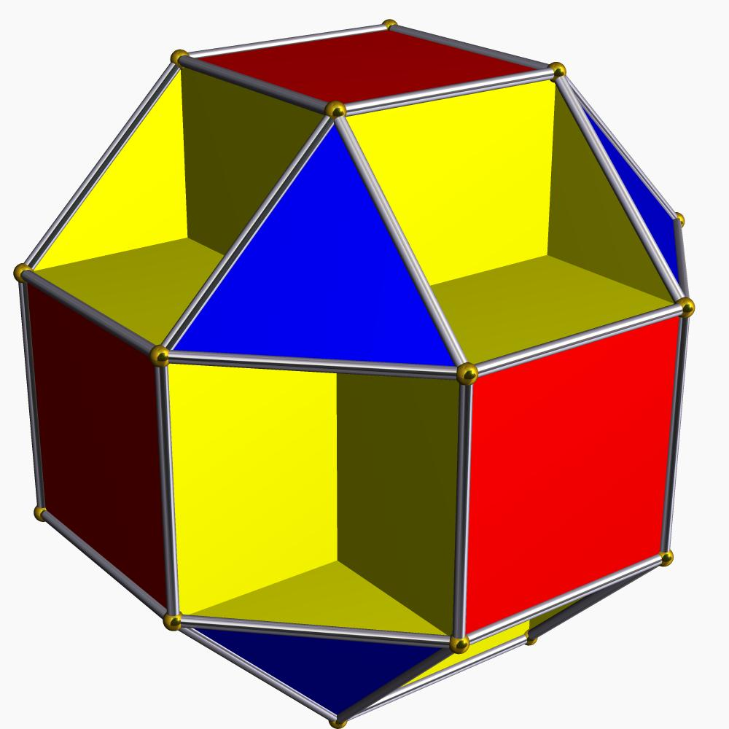
Small Cubicuboctahedron
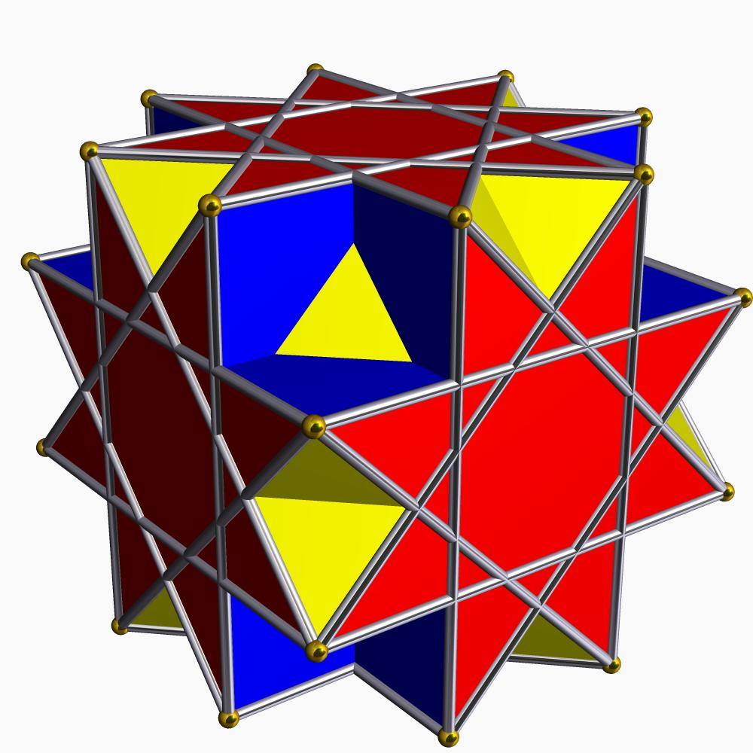
Great Cubicuboctahedron
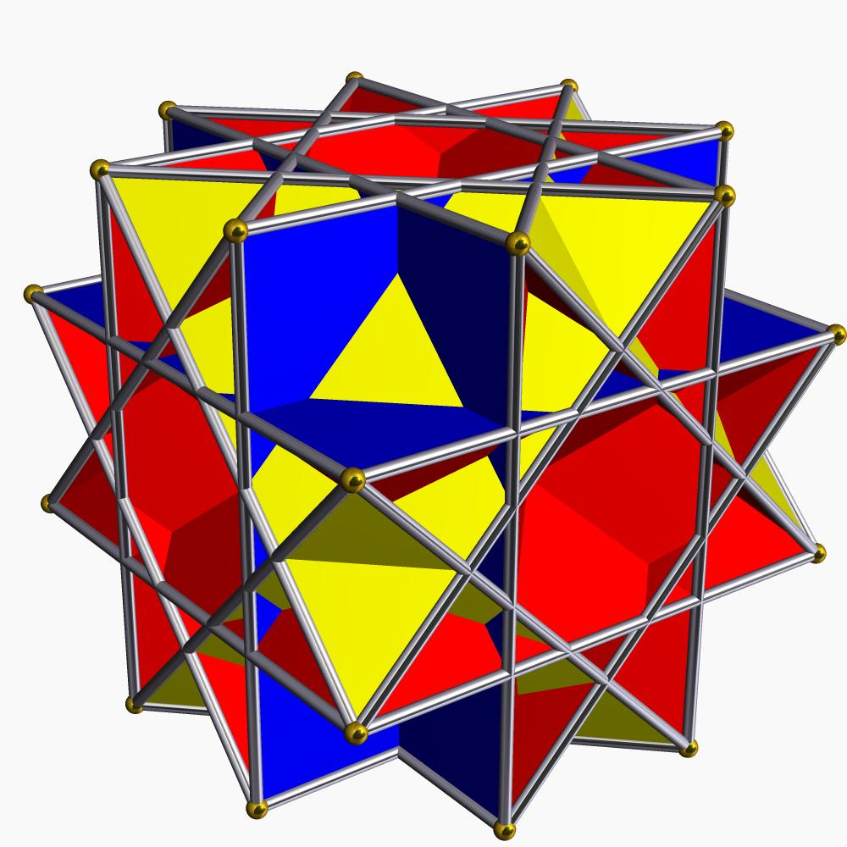
Great Rhombicuboctahedron
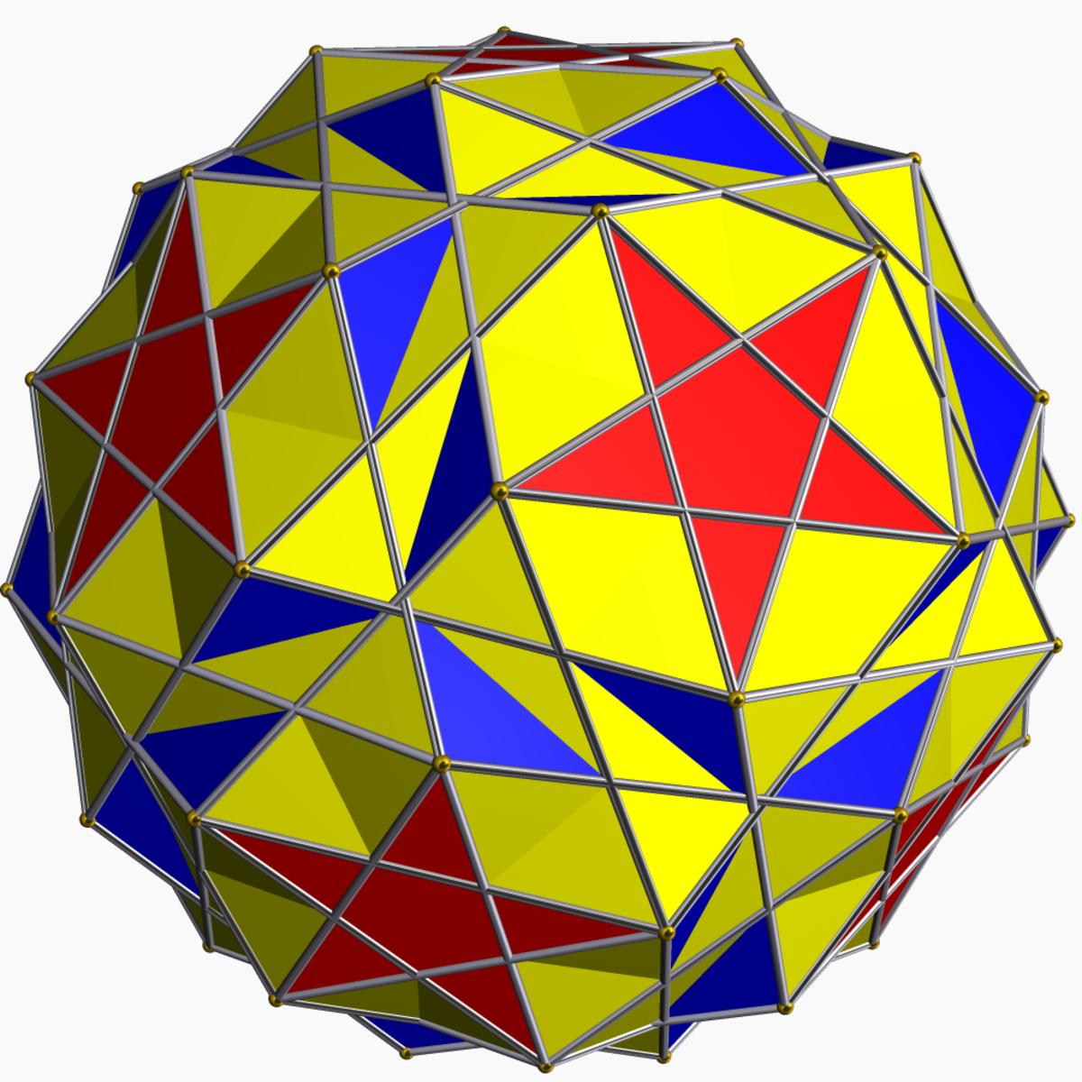
Snub Dodecadodecahedron
The semiregular category contains 39 non-prismatic uniform star polyhedra.

Uniform Star Prisms
# Source: AI Source: Provided by: [Data Path: Persons Table -> ID Column: 1, Name_En Column: Motasem Essam] -> From: [ChatGPT] on [7/25/2026]
Uniform Star Prisms are an infinite family of non-convex uniform polyhedra formed by extending a regular star polygon along a perpendicular axis.
Their general structure consists of:
- Two parallel, congruent star-polygon bases.
- Rectangular lateral faces.
- Uniform vertices around both bases.
Their star-polygon bases can be represented using:
$$\{\frac{n}{d}\}$$
where:
- $n$ = number of polygon vertices.
- $d$ = connection step.
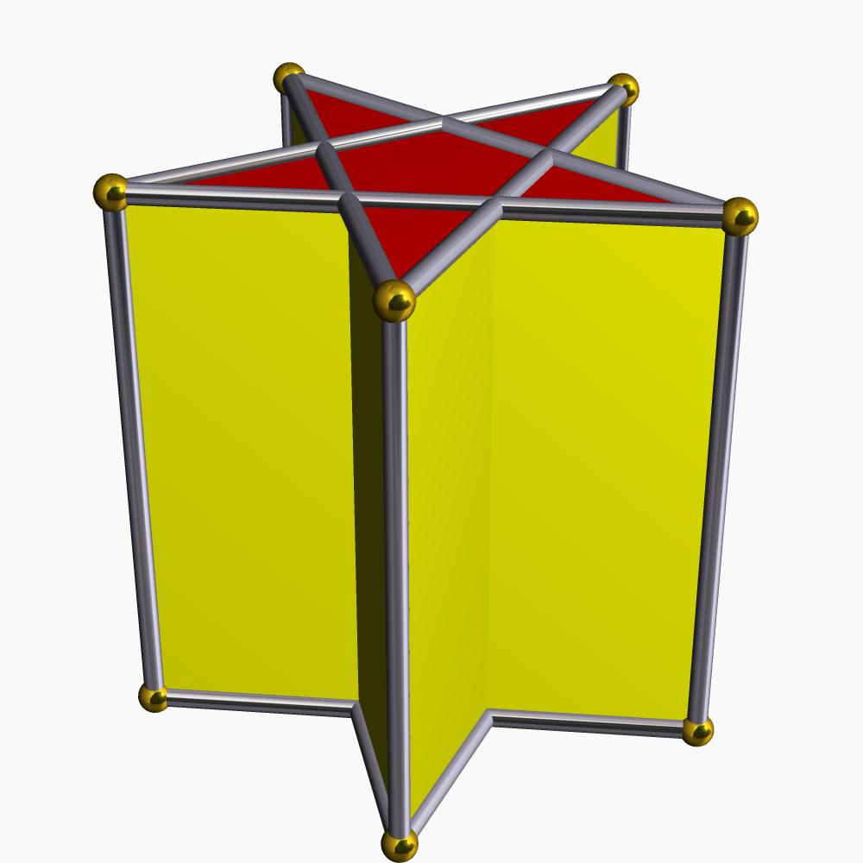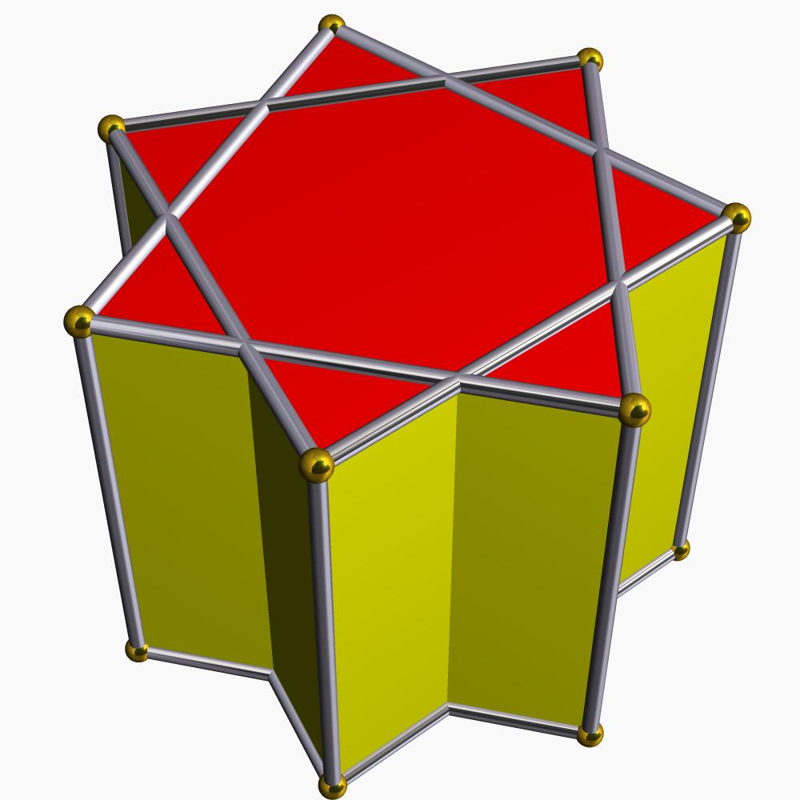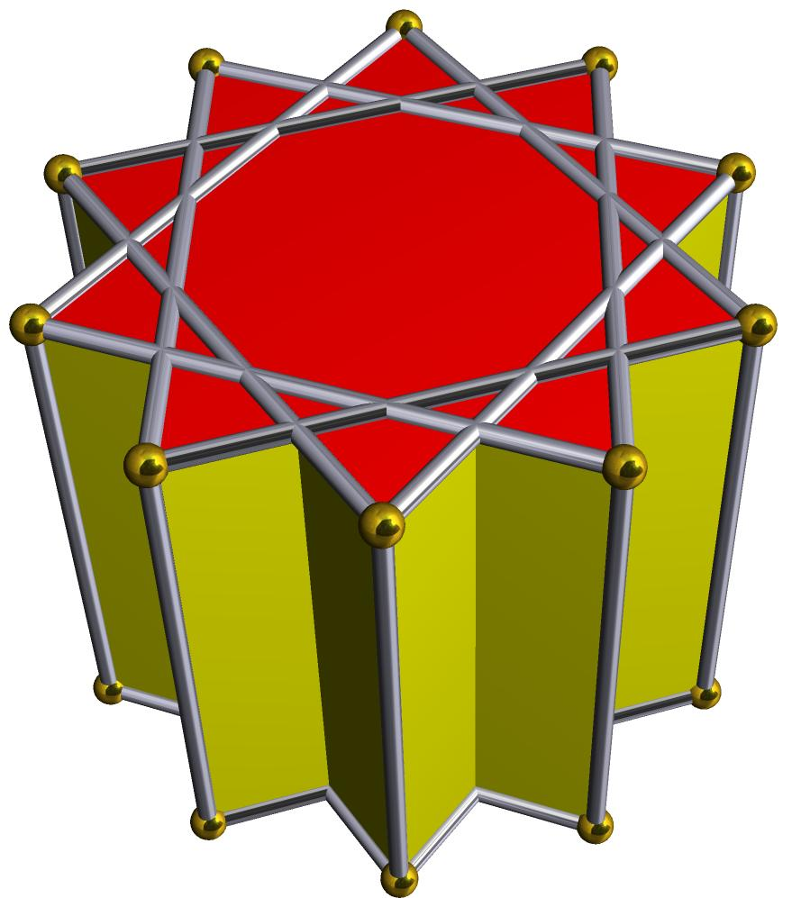

Uniform Star Antiprisms
# Source: AI Source: Provided by: [Data Path: Persons Table -> ID Column: 1, Name_En Column: Motasem Essam] -> From: [ChatGPT] on [7/25/2026]
Uniform Star Antiprisms are an infinite family of non-convex uniform polyhedra formed using two parallel star-polygon bases with a relative rotation.
Their structure consists of:
- Two parallel, congruent star-polygon bases.
- Alternating triangular lateral faces.
- A twisted arrangement of vertices.
- Uniform vertex configurations.
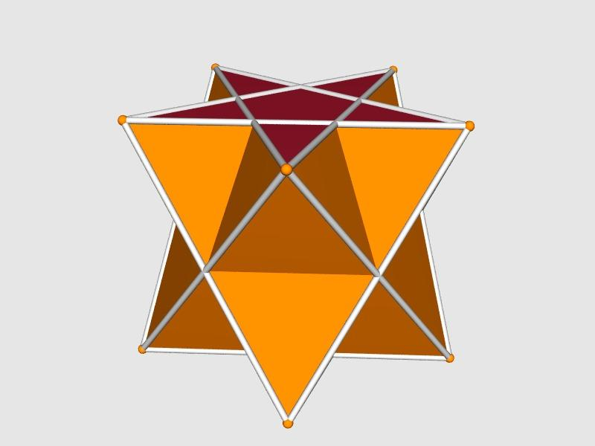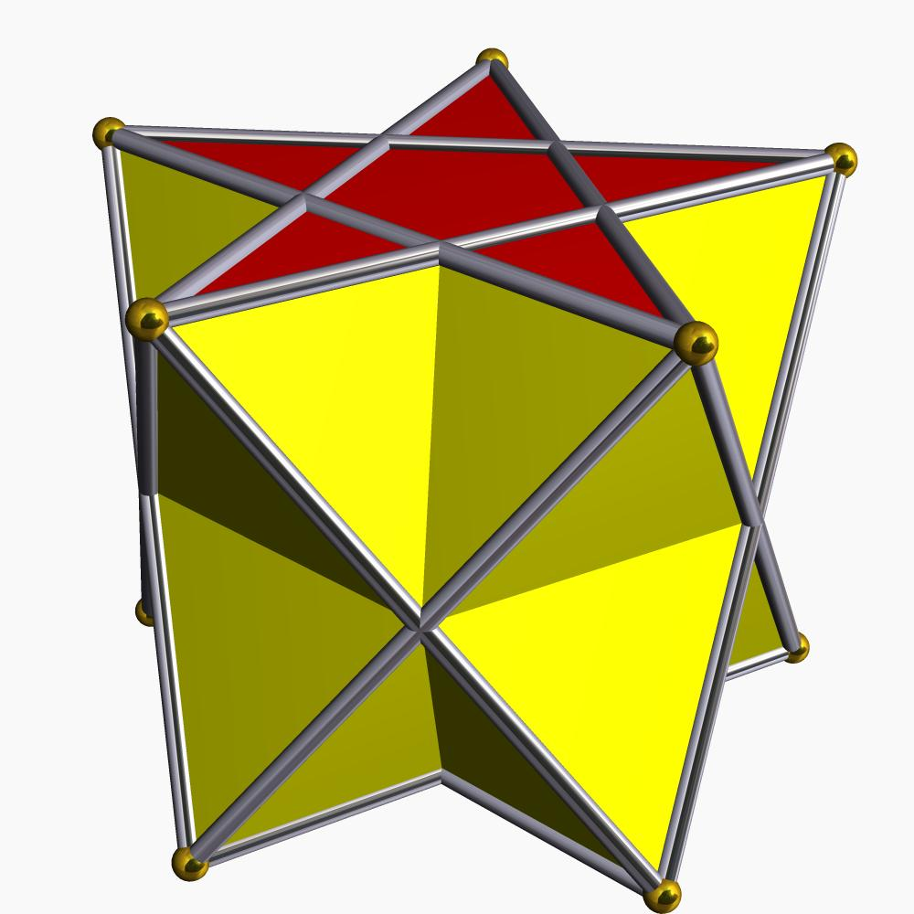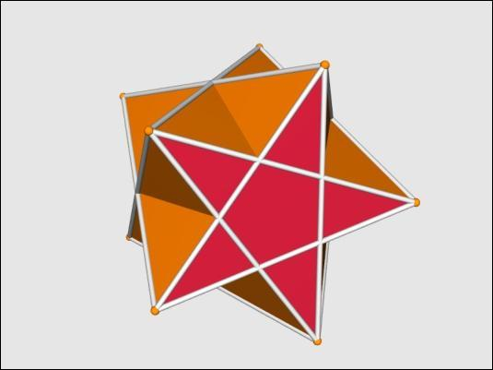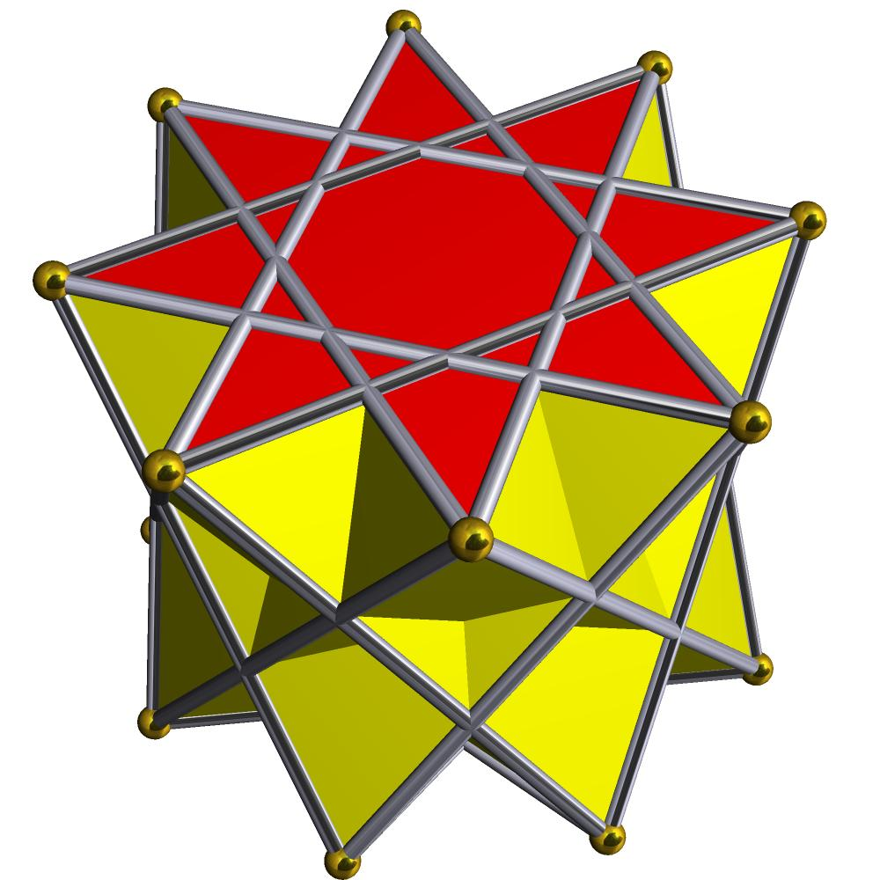
Both uniform star prisms and uniform star antiprisms extend the classification beyond the 57 non-prismatic forms.

Mathematical Properties
# Source: AI Source: Provided by: [Data Path: Persons Table -> ID Column: 1, Name_En Column: Motasem Essam] -> From: [ChatGPT] on [7/25/2026]
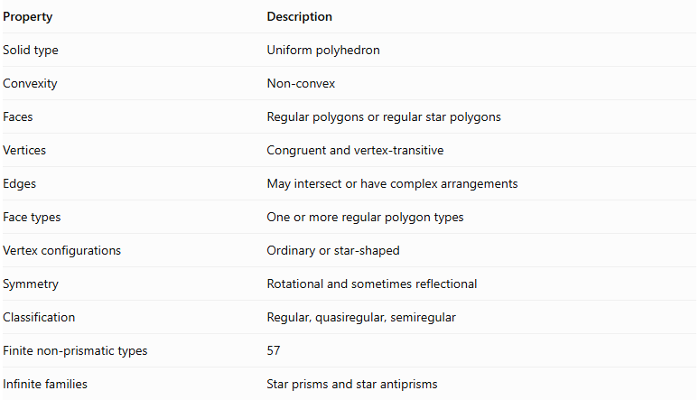
Property | Description
Solid type | Uniform polyhedron
Convexity | Non-convex
Faces | Regular polygons or regular star polygons
Vertices | Congruent and vertex-transitive
Edges | May intersect or have complex arrangements
Face types | One or more regular polygon types
Vertex configurations | Ordinary or star-shaped
Symmetry | Rotational and sometimes reflectional
Classification | Regular, quasiregular, semiregular
Finite non-prismatic types | 57
Infinite families | Star prisms and star antiprisms

Polygonal Face Notation
# Source: AI Source: Provided by: [Data Path: Persons Table -> ID Column: 1, Name_En Column: Motasem Essam] -> From: [ChatGPT] on [7/25/2026]
Uniform star polyhedra use regular polygon and star-polygon notation.
A star polygon is represented by:
$$\{\frac{n}{d}\}$$
where $n$ is the number of vertices and $d$ is the step used to connect them.
Examples:
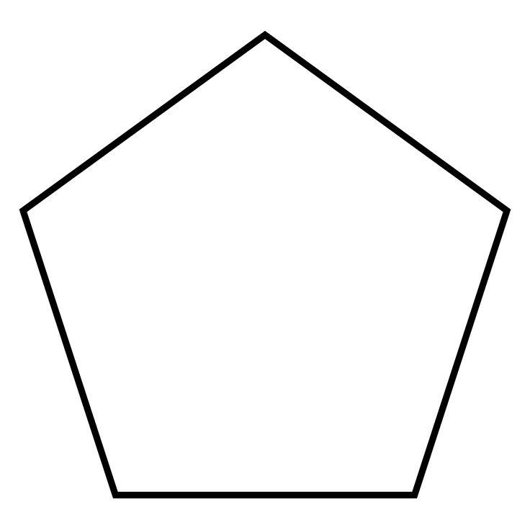
Pentagon
$$\{5\}$$
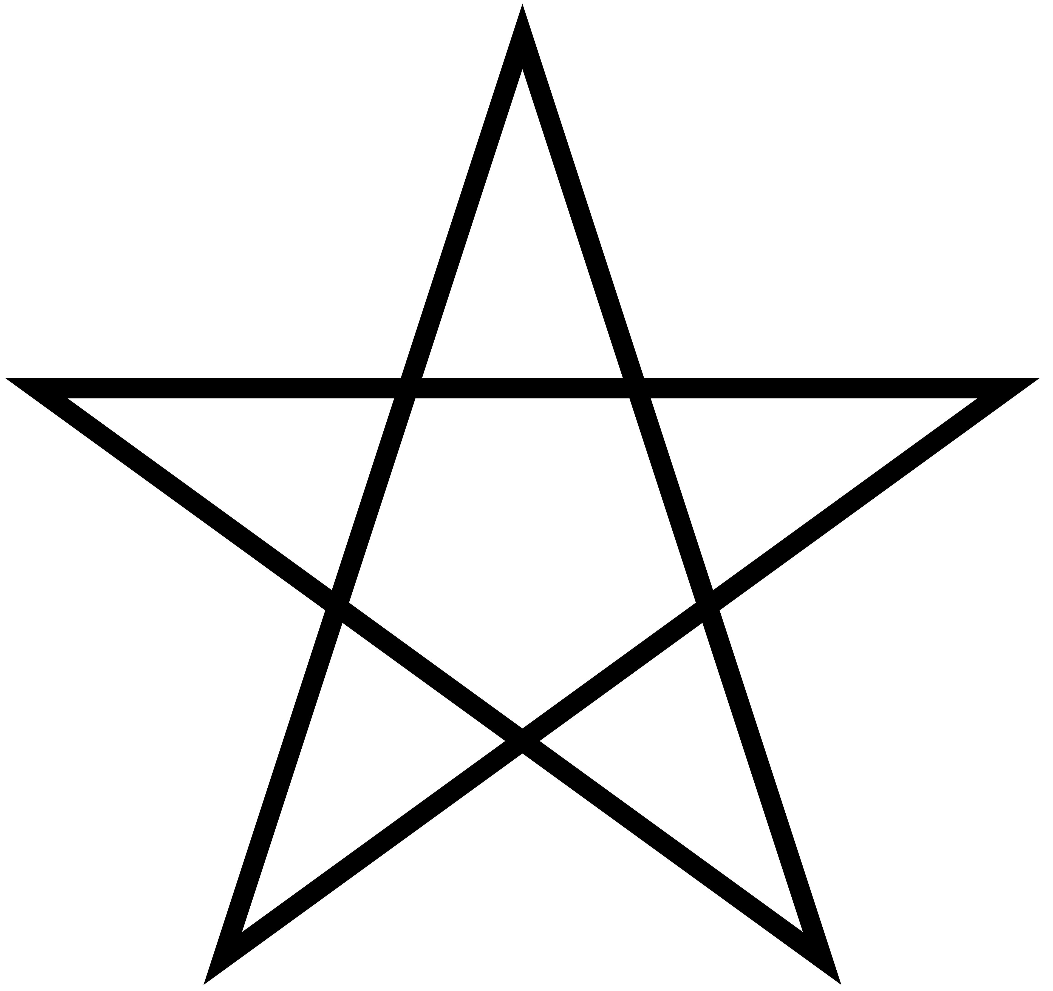
Pentagram
$$\{5/2\}$$
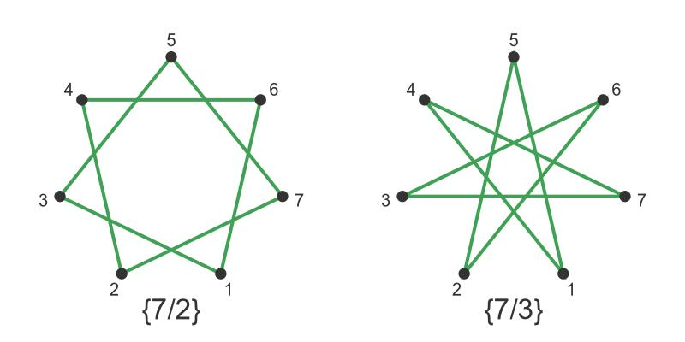
Heptagram
$$\{7/2\}$$
The notation distinguishes ordinary convex polygons from star polygons, which have self-intersecting boundaries.

Vertex Configuration
# Source: AI Source: Provided by: [Data Path: Persons Table -> ID Column: 1, Name_En Column: Motasem Essam] -> From: [ChatGPT] on [7/25/2026]
The vertex configuration describes the sequence of polygonal faces surrounding a vertex.
For example:
$$3.3.3.3.4$$
describes four triangular faces and one square around each vertex.
Star polygons can also appear in vertex configurations:
$$3.3.\frac{5}{2}.3.5$$
Here, $\frac{5}{2}$ represents a pentagrammic element in the vertex arrangement.
Since a uniform polyhedron is vertex-transitive, the same vertex configuration occurs at every vertex.

Symmetry and Construction
# Source: AI Source: Provided by: [Data Path: Persons Table -> ID Column: 1, Name_En Column: Motasem Essam] -> From: [ChatGPT] on [7/25/2026]
Uniform star polyhedra are commonly constructed using Wythoff's construction, which generates polyhedra from symmetry groups and selected positions within their fundamental regions.
Their symmetry groups include:
- Tetrahedral symmetry.
- Octahedral symmetry.
- Icosahedral symmetry.
- Dihedral symmetry for prismatic families.
Some snub polyhedra have only rotational symmetry and occur in two mirror-image forms, known as left-handed and right-handed forms.

Comparison with Other Polyhedron Categories
# Source: AI Source: Provided by: [Data Path: Persons Table -> ID Column: 1, Name_En Column: Motasem Essam] -> From: [ChatGPT] on [7/25/2026]
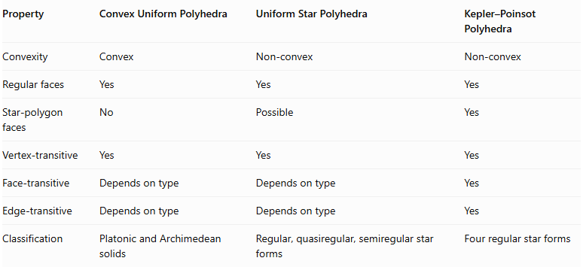
Property | Convex Uniform Polyhedra | Uniform Star Polyhedra | Kepler–Poinsot Polyhedra
Convexity | Convex | Non-convex | Non-convex
Regular faces | Yes | Yes | Yes
Star-polygon faces | No | Possible | Yes
Vertex-transitive | Yes | Yes | Yes
Face-transitive | Depends on type | Depends on type | Yes
Edge-transitive | Depends on type | Depends on type | Yes
Classification | Platonic and Archimedean solids | Regular, quasiregular, semiregular star forms | Four regular star forms
Important distinction: Kepler–Poinsot polyhedra are not a separate category outside uniform star polyhedra. They are the regular subgroup of the uniform star polyhedra.

Main Classification
# Source: AI Source: Provided by: [Data Path: Persons Table -> ID Column: 1, Name_En Column: Motasem Essam] -> From: [ChatGPT] on [7/25/2026]
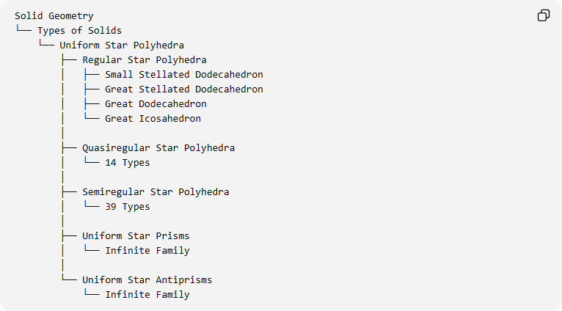
Solid Geometry
└── Types of Solids
└── Uniform Star Polyhedra
├── Regular Star Polyhedra
│ ├── Small Stellated Dodecahedron
│ ├── Great Stellated Dodecahedron
│ ├── Great Dodecahedron
│ └── Great Icosahedron
│
├── Quasiregular Star Polyhedra
│ └── 14 Types
│
├── Semiregular Star Polyhedra
│ └── 39 Types
│
├── Uniform Star Prisms
│ └── Infinite Family
│
└── Uniform Star Antiprisms
└── Infinite Family

Key Points
# Source: AI Source: Provided by: [Data Path: Persons Table -> ID Column: 1, Name_En Column: Motasem Essam] -> From: [ChatGPT] on [7/25/2026]
- Uniform star polyhedra are non-convex uniform polyhedra.
- Their faces are regular polygons or regular star polygons.
- Every vertex has an identical geometric arrangement.
- They can contain intersecting faces and star-shaped vertex figures.
- There are 57 non-prismatic uniform star polyhedra.
- They are classified into 4 regular, 14 quasiregular, and 39 semiregular forms.
- Uniform star prisms and uniform star antiprisms form two additional infinite families.
- The Kepler–Poinsot polyhedra are the four regular uniform star polyhedra.

Conclusion
# Source: AI Source: Provided by: [Data Path: Persons Table -> ID Column: 1, Name_En Column: Motasem Essam] -> From: [ChatGPT] on [7/25/2026]
Uniform Star Polyhedra form an important category of three-dimensional geometry that extends regular and uniform polyhedral structures beyond convex solids. Their combinations of regular polygons, star polygons, intersecting faces, and uniform vertex arrangements produce a broad family of highly symmetrical geometric forms.
The classification includes regular, quasiregular, and semiregular star polyhedra, together with infinite families of star prisms and star antiprisms.

